Melissa Moreno

July 14, 2016

Lab 9- Museum Activity

The Florida Giant Armadillo- Like Grazer

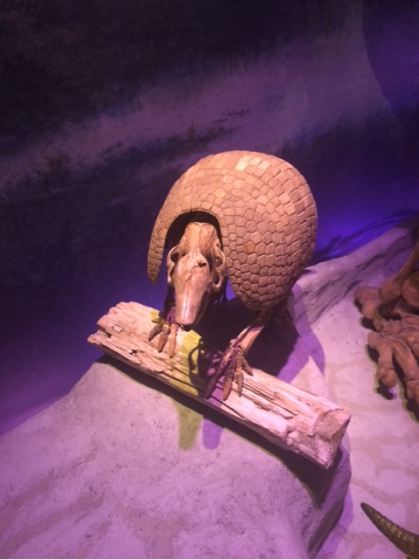

Around 2.2 to 1 million years ago, Florida was a completely different place. During the Pliocene-Pleistocene period, Florida was known to have large flora and fauna. Everything was huge during that era. This is because the Pleistocene was during one the last ice ages. The climate was cooler and drier. Florida was known to have an impressive amount of mammals during this time. Florida was also much wider at the time, so there was a great opportunity for animals to migrate across the state especially since Florida was known to have a relatively consistent climate, of course factoring in wet and dry seasons. This was also a period where animals and flora were very large. There was competition, but much more land mass in Florida for animals to create a home range.

The current armadillo in Florida, Dayspus novemcinctus, is around 15- 17 inches long (without the tail) and a total of 8-17 lbs. The ancestor Holmesina floridanus measured 1.5 meters, while the later anscestor Holmesina septentrionalis was 2 meters and weighed half a ton. Holmesina floridanus migrated to Florida from South America. Their large size would have made it easier to migrate long distances. This animal would most likely move far distances in order to find suitable shelter and food during the changing climates. Armadillos are part of the family Cingulata, which are xantharans with shells. They are also known to have ever- growing teeth, which made them very suitable to eat abrasive grasses, which means they could eat an array of different vegetation during their migration. Evolutionary advancement on the teeth could have risen from other animal/ food competition as well as landscape change. Currently modern armadillos are omnivorous but still mainly consume on grasses. Holmesina died around 10,000, which shows evidence that the arrival of humans during this time played a role in its disappearance, along with many other species.

My proposed literature search would be to search for fossils or records during the time of Holmesina in Florida. I would propose to do research specifically when this species arrived in Florida and what kind of behaviors did it exihibit. I searched using the genus and species name, as well as on the Florida Museum of Natural History website.

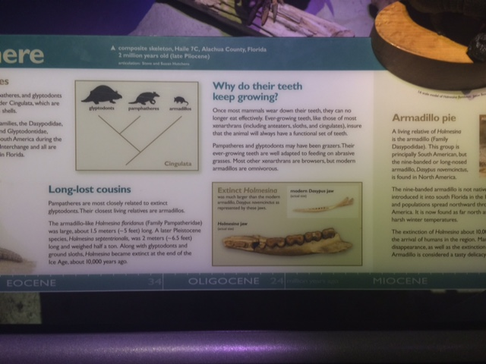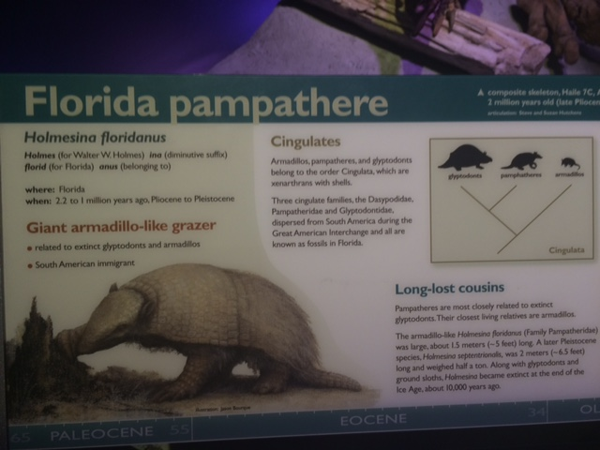

(I didn’t read the lab beforehand, so I don’t have a picture with me in them, but I do have the pictures on my phone with the date taken in the Camera roll, to show that I did choose this display.)